Half Termly Curriculum Highlight

Subject: Computing

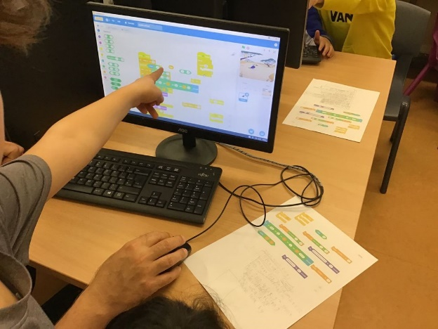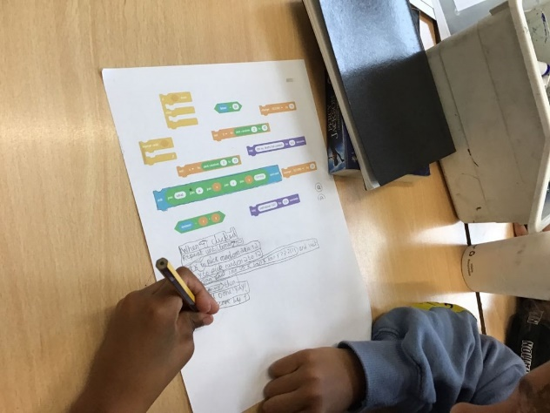

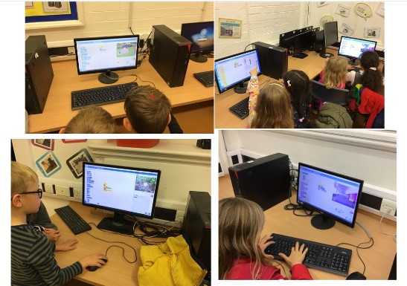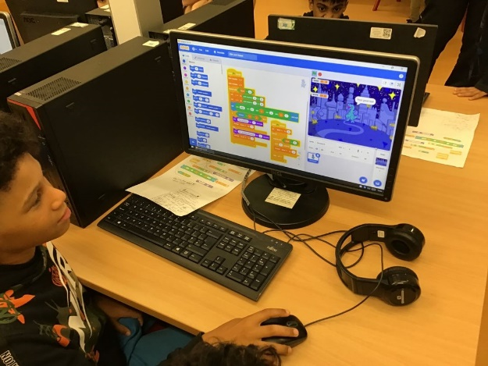

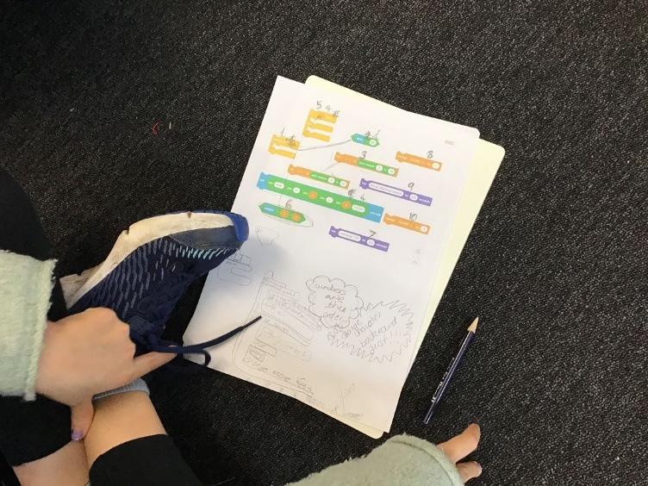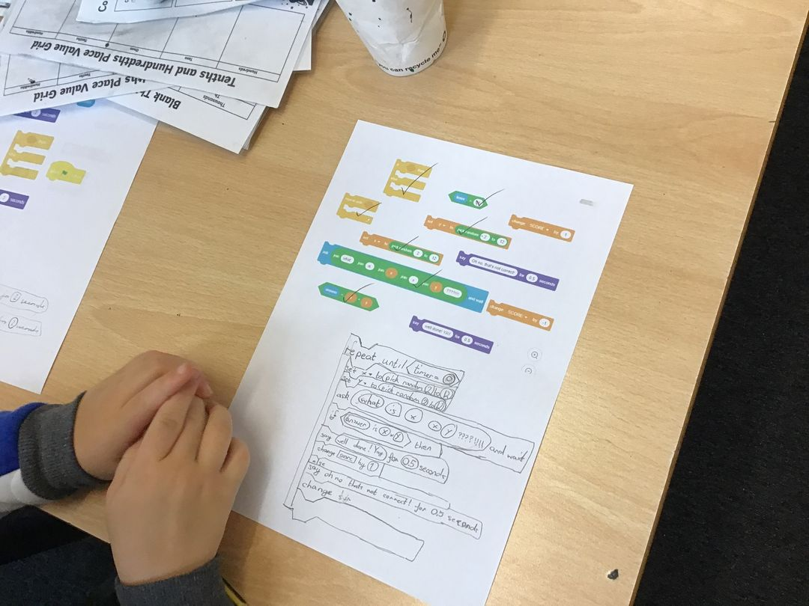

Meet the Subject Lead



**Ben Caldwell**

Ben has been the Computing subject lead at Oswald Road for the past three years. He loves creating projects in Scratch and discovering exciting new apps which can be used across the school curriculum. During this time, Ben has overseen significant changes to the way Computing is delivered in the school and has taught a range of different Computing projects to all year groups throughout the school.

The Computing Curriculum

Changes to the National Curriculum in 2014 saw the introduction of a new primary school subject: Computing. This replaced the old subject of Information and Communication Technology (ICT). Whereas ICT was geared towards making pupils proficient users of software programs such as Microsoft Word and Microsoft Excel, Computing has a much stronger focus on Computer Science and requires pupils to develop their programming and coding abilities. By exposing pupils to a range of computational thinking skills, the Computing curriculum aims to make pupils experts in producing and creating their own digital content rather than being passive consumers of existing computer software.

The Computing curriculum is split into three strands:

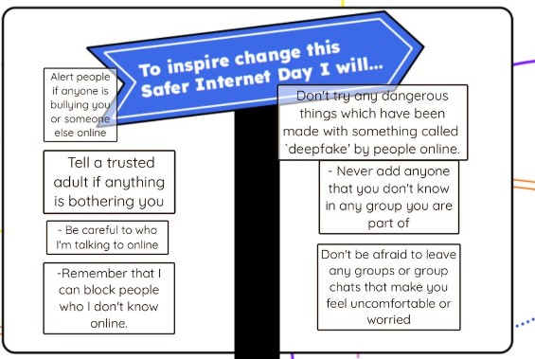**Digital Literacy** – This aspect of the curriculum is focussed on online behaviour and aims to ensure pupils know how to stay safe and act responsibly online.

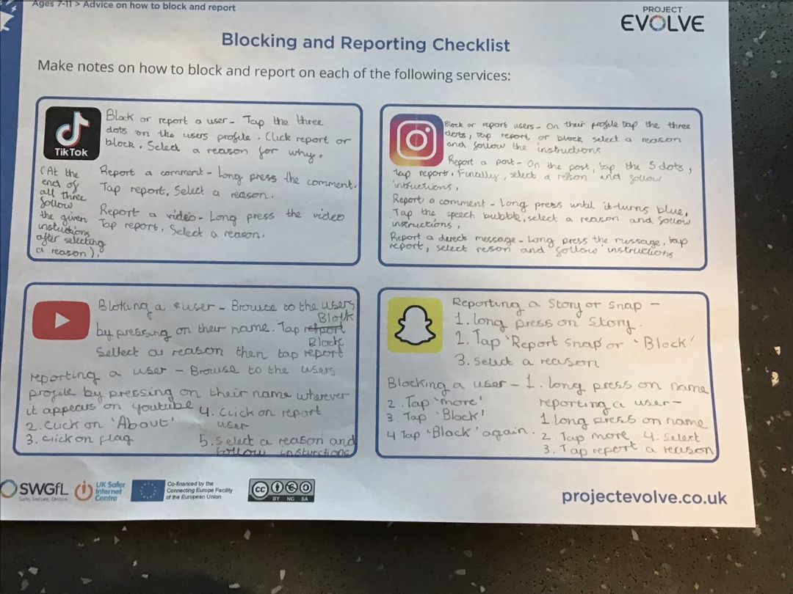

**Information Technology** – This strand of the curriculum mirrors a lot of the content of the old ICT curriculum and aims to make pupils confident users of a range of different computer programs and applications. Compared to the old ICT curriculum, however, there is a stronger focus on pupils using these applications to create their own original content.



**Computer Science** – The goal of this area of the curriculum is to ensure that pupils can understand and apply the key concepts of computer science such as abstraction, decomposition, logic, algorithms and data representation. This strand of the curriculum requires pupils to analyse problems in computational terms, and gain practical experience of writing computer programs in order to solve such problems.

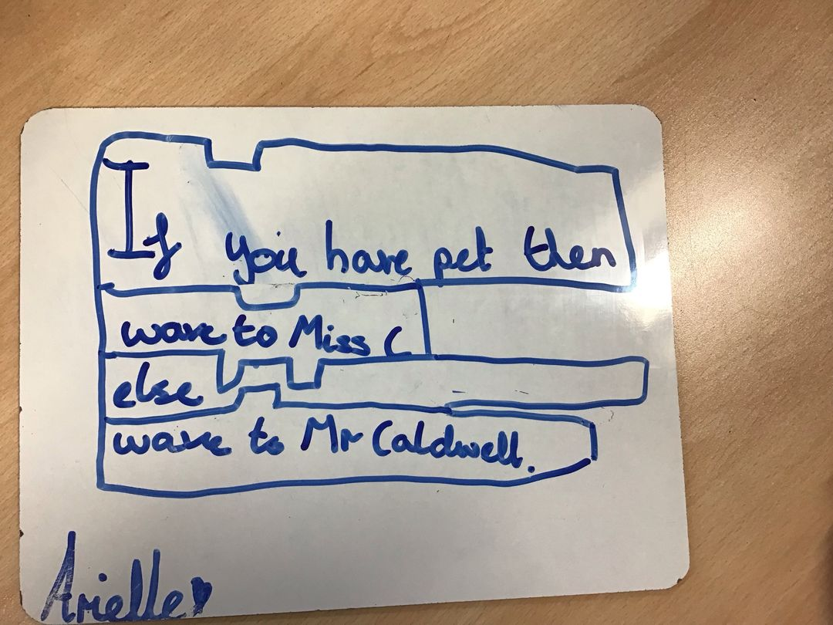

Computing at Oswald Road

All three strands of the Computing curriculum are delivered throughout the school. Digital Literacy lessons are taught by the class teacher, with each half term focussing on a different aspect of Internet safety and responsible online behaviour:

Autumn 1 - Managing Online Information. Online Reputation.

Autumn 2 - Online Bullying.

Spring 1 - Copyright and Ownership. Privacy and Security.

Spring 2 - Health, Wellbeing and Lifestyle.

Summer 1 - Online Relationships.

Summer 2 - Self Image and Identity.



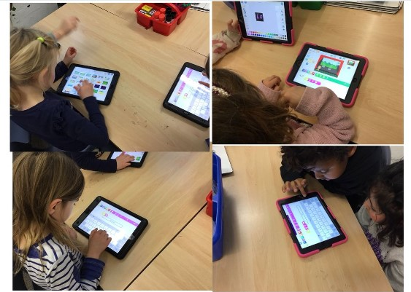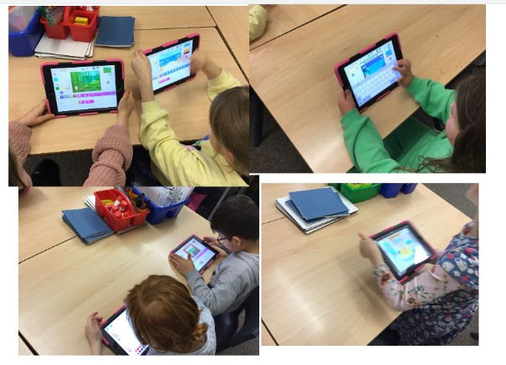The Information Technology area of the curriculum is covered in a range of different subjects. In this cross-curricular approach, pupils across the school may use a variety of different computer programs and applications to create work and enhance their learning in subjects such as history, geography, maths, music and art.

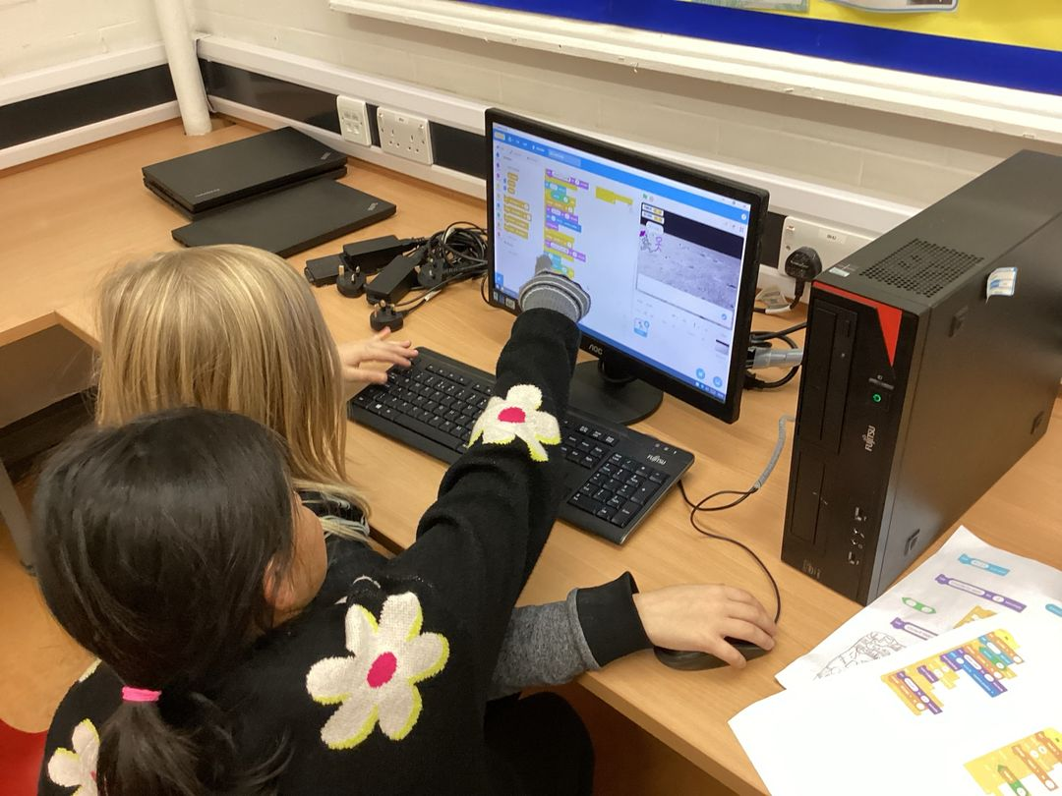The Computer Science strand of the Curriculum is delivered by Mr Caldwell across the school. As this aspect of the curriculum is focussed on the pupils developing their coding and programming skills, the majority of lessons are centred around a program called Scratch. This free-to-use software has been developed by the Massachusetts Institute of Technology and is a visual programming tool which allows pupils to arrange a wide variety of different coding blocks in order to create their own algorithms. In KS1 pupils use the Scratch Junior app on iPads and in KS2 they use the desktop version which has a wider range of capabilities.

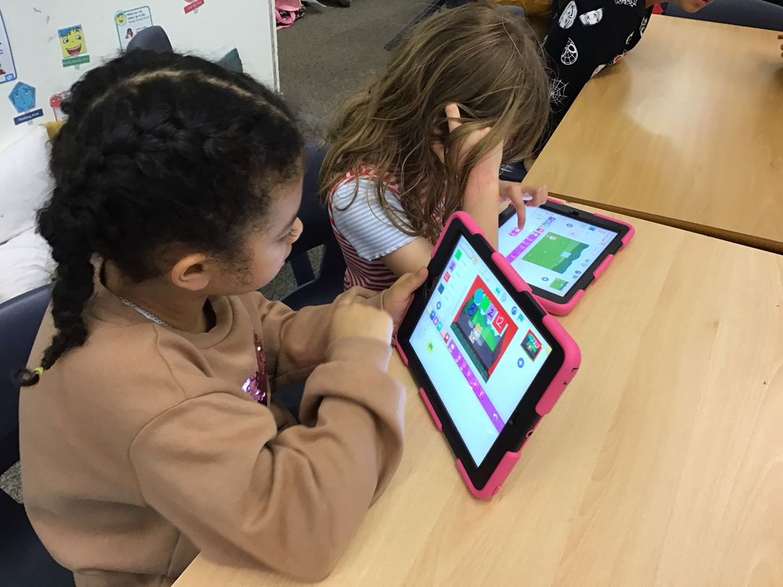

Digital Ambassadors

Earlier this month a group of Year 5 pupils accompanied Mr Caldwell to a workshop held by the Manchester Safeguarding partnership. These pupils will now be the Digital Ambassadors for Oswald Road and will help to deliver a project about reducing online bullying and ensuring that pupils know how stay safe and happy in a range of different online situations.

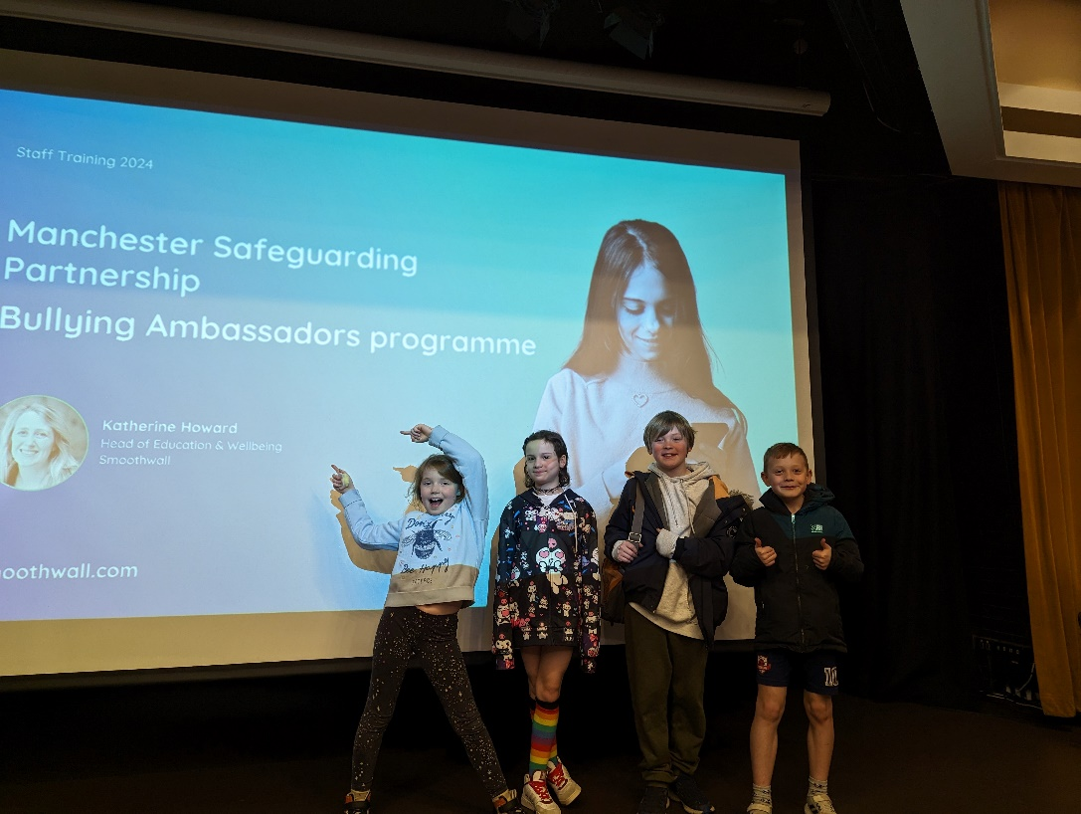

Pupil voice

**“I love creating projects in Scratch!”**

**“Computing is DEFINITELY my favourite lesson”**

**“I like it when I work out how to do something new in Scratch”**

**“It’s cool that I know how to code my own games!”**

**“I love Computing because it’s super interesting”**

**“I liked it when we made our times tables game in Scratch”**

**“It’s really fun when we get to go on the computers and make our own projects. This year we made our own maze games and that was very cool!”**

**“I wish we could do Computing every day!”**