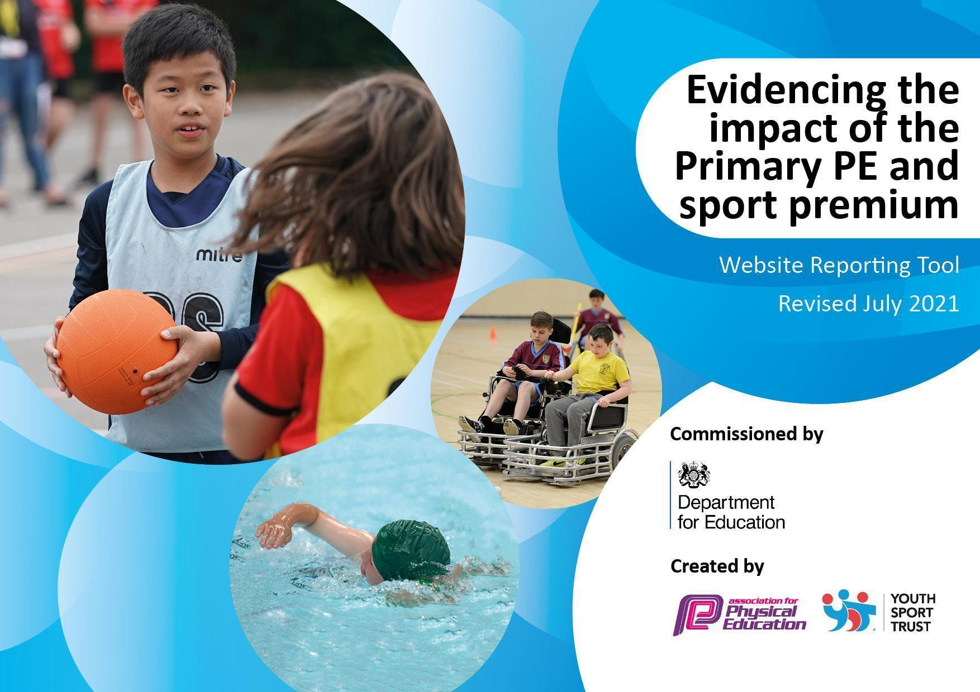

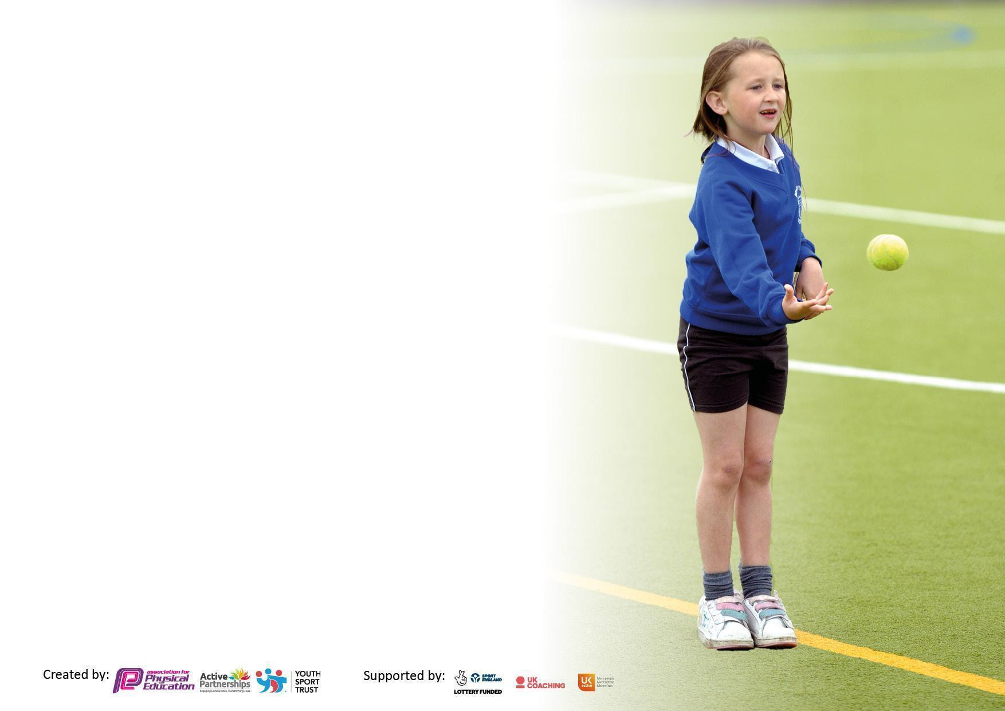

It is important that your grant is used effectively and based on school need. The Education Inspection Framework makes clear there will be a focus on **‘whether leaders and those responsible for governors all understand their respective roles and perform these in a way that enhances the effectiveness of the school’**.

Under the Quality of Education Ofsted inspectors consider:

**Intent** - Curriculum design, coverage and appropriateness

**Implementation** - Curriculum delivery, Teaching (pedagogy) and Assessment

**Impact** - Attainment and progress

To assist schools with common transferable language this template has been developed to utilise the same three headings which should make your plans easily transferable between working documents.

Schools must use the funding to make **additional and sustainable** improvements to the quality of Physical Education, School Sport and Physical Activity (PESSPA) they offer. This means that you should use the Primary PE and sport premium to:

* Develop or add to the PESSPA activities that your school already offer
* Build capacity and capability within the school to ensure that improvements made now will benefit pupils joining the school in future years
* The Primary PE and sport premium should not be used to fund capital spend projects; the school’s budget should fund these.

Pleasevisitgov.ukfortherevisedDfEguidanceincludingthe5keyindicatorsacrosswhichschoolsshoulddemonstrate animprovement.Thisdocumentwillhelpyoutoreviewyourprovisionandtoreportyourspend.DfEencouragesschools to use this template as an effective way of meeting the reporting requirements of the Primary PE and sport premium.

We recommend you start by reflecting on the impact of current provision and reviewing the previous spend.

Schools are required to publish details of how they spend this funding, including any under-spend from 2019/2020, as well as on the impact it has on pupils’ PE and sport participation and attainment. **All funding must be spent by 31st July 2022.**

We recommend regularly updating the table and publishing it on your website throughout the year. This evidences your ongoing self-evaluation of how you are using the funding to secure maximum, sustainable impact. Final copy must be posted on your website by the end of the academic year and no later than the 31st July 2021. To see an example of how to complete the table please click HERE.

Created by: Supported by:



| Total amount carried over from 2023 | £1350 |
| --- | --- |
| Total amount allocated for 2023/24 | £21,279 |
| How much (if any) do you intend to carry over from this total fund into 2023/24? | £0 |
| Total amount allocated for 2023/24 | £21,110 |
| Total amount of funding for 2023/4. To be spent and reported on by 31st July 2024. | £21,110 |



| Meeting national curriculum requirements for swimming and water safety.  N.B. Complete this section to your best ability. For example you might have practised safe self-rescue techniques on dry land which you can then transfer to the pool when school swimming restarts.  **Due to exceptional circumstances priority should be given to ensuring that pupils can perform safe self rescue even if they do not fully meet the first two requirements of the NC programme of study** | 2023-2024 | 2024-2025 |
| --- | --- | --- |
| What percentage of your current Year 6 cohort swim competently, confidently and proficiently over a distance of at least 25 metres?  **N.B.** Even though your pupils may swim in another year please report on their attainment on leaving primary school at the end of the summer term 2022.  Please see note above | 82% | 82% |
| What percentage of your current Year 6 cohort use a range of strokes effectively [for example, front crawl, backstroke and breaststroke]?  Please see note above | 71% | 59% |
| **What percentage of your current Year 6 cohort perform safe self-rescue in different water-based situations?** | 86% | 82% |
| Schools can choose to use the Primary PE and sport premium to provide additional provision for swimming but this must be for activity **over and above** the national curriculum requirements. Have you used it in this way? | Yes/No |  |

**To note:** Due to the importance of swimming and the fact these children missed out on swimming during Year 4, school has offered (and promoted on several occasions) children accessing school-paid swimming lessons during the summer holiday (summer 22). This is funded outside of the Sports Premium.



| **Academic Year:** 2024 - 2025 | | **Date Updated: August 2024** | |  |
| --- | --- | --- | --- | --- |
| **Key indicator 1:** The engagement of all pupils in regular physical activity – Chief Medical Officers guidelines recommend that primary school pupils undertake at least 30 minutes of physical activity a day in school.  **£10,000** | | | | Percentage of total allocation: |
|  |
| **Intent** | **Implementation** | | **Impact** |  |
| Your school focus should be clear what you want the pupils to know and be able to do and about  what they need to learn and to  consolidate through practice: | Make sure your actions to achieve are linked to your intentions: | Funding allocated: | Evidence of impact: what do pupils now know and what can they now do? What has changed?: | Sustainability and suggested next steps: |
| To increase extra curricular physical exercise opportunities across school.  Increased amount of after school clubs to allow for further engagement | Additional lunchtime clubs run by our sports coaches (2x one hour & 4x one hour; clubs for four year groups)  4 x after school sports clubs | £7,000  £3,000 | Uptake in activity data  Pupil voice  Pupil voice  Pupil voice (Play Leaders)  Pupil voice (other children) | All additional lunchtime clubs in place and impact noted through pupil voice, lunchtime organiser feedback and behaviour incidents (particular year groups).  After School Club sports offer in place.  Autumn  Sportspoint - 30 children (Years 1 - 6)  Hoot Camp - 27 children (Years 2-5)  Spring  Sportspoint - 34 (Years 1-6)  Sports with Owl Club - 30 (Years 2-5)  Creative Owls - Multisports 40 (Years 1-6)  Creative Owls - Netbusters - 22 (Years 2-6)  Summer  Sportspoint - 37 (Years 1-6)  Creative Owls - Multisports 17 (Years 1-6)  Creative Owls - Netbusters - 22 (Years 2-6) |
| **Key indicator 2:** The profile of PESSPA being raised across the school as a tool for whole school improvement  **£500** | | | | Percentage of total allocation: |
|  |
| **Intent** | **Implementation** | | **Impact** |  |
| Your school focus should be clear what you want the pupils to know and be able to do and about  what they need to learn and to  consolidate through practice: | Make sure your actions to achieve are linked to your intentions: | Funding allocated: | Evidence of impact: what do pupils now know and what can they now do? What has changed?: | Sustainability and suggested next steps: |
| To raise the profile of sports on a whole school level  To raise profile of sporting events and participation in these  To raise profile of sport and physical activity | Annual Sports Day held with activities including: sprinting, hockey, throwing, football and long jump.  To continue to promote to ensure strong parental engagement.  To continue to listen to pupil and staff voice to adapt as needed.  To consider date of Sports Day to ensure all children are able to participate.  To continue to liaise with SEND team to ensure all children can participate.  Release for PE leads for planning  Release for PE leads on Sports Day  To post photos on social media, write newsletter articles etc to further raise the profile.  To celebrate different sporting events in assembly. | £0  £200  £300 | Sports day to be booked in on QAC.  Parental voice.  Pupil voice and staff voice.    PS and BC to liaise with SEND team.  Celebrate in assembly. We are reporting on sporting events in weekly newsletter and assembly.  Raise profile using in school display. | All in place. Staff feedback strong and parents noted on the day that they enjoyed the event.  DL has led parent showcases for all year groups. Parental numbers were good for these.  In place.  In place.  In place. Regulation stations to be considered for next year.  In place.  In place.  In place. Individual sporting achievements from outside of school covered in parental newsletter and assemblies.  In school, achievements are celebrated in assemblies. |

| **Key indicator 3:** Increased confidence, knowledge and skills of all staff in teaching PE and sport  **£7,900** | | | | Percentage of total allocation: |
| --- | --- | --- | --- | --- |
|  |
| **Intent** | **Implementation** | | **Impact** |  |
| Your school focus should be clear | Make sure your actions to | Funding | Evidence of impact: what do | Sustainability and suggested |
| what you want the pupils to know | achieve are linked to your | allocated: | pupils now know and what | next steps: |
| and be able to do and about | intentions: |  | can they now do? What has |  |
| what they need to learn and to |  |  | changed?: |  |
| consolidate through practice: |  |  |  |  |
| To further increase subject leader knowledge of their subject areas, developing subject specialist.  To provide a well-planned, well-sequenced curriculum for our children, that teachers can deliver with increased confidence.  To keep up to date with current PE practices.  Supporting teachers with the delivery of PE through specialist sports coach. | Release for PE leads to continue to finely tune the curriculum mapping.  Release for PE leads to observe PE teaching and speak to teachers and children.  Continue to attend cluster meetings with specific assessment agenda (release needed)  Working with SENDCo and Curriculum Lead on SEND adaptations within curriculum – both curriculum differentiation and pedagogy.  Subscription to PE Passport  Gym and dance to be taught alongside sports coach.  Sports coach to look over planning and give feedback to teachers.  Sports coach to liaise with Gym and Dance leads. | £1000  £900  £6000 | BC dance. PS Gym. CB Outdoor activity.  CB and BC to attend cluster meetings  Time to feedback.  Continue subscription.  PS to liaise with DL on gym and dance curriculum.  Staff voice.  Pupil voice. | In place.  Dance - all unit plans, assessment work following Mel Hooson training and other relevant documents updated for next academic year.  Gym - Assessment work following Mel Hooson training  Outdoor - Assessment work following Mel Hooson training.  2 clusters attended and relevant information disseminated to staff and SLT. SLT feedback session completed to update following actions from Tim Nelson’s Deep Dive last year.  Adaptation document in place. To be worked on further.  Continuation with PE Passport considered **Paul please update.  In place until and DL moved to Sports Coach role in Spring.  In place.  In place. |
| **Key indicator 4:** Broader experience of a range of sports and activities offered to all pupils  **£500 (a lot costed in previous section – cross over)** | | | | Percentage of total allocation: |
|  |
| **Intent** | **Implementation** | | **Impact** |  |
| Your school focus should be clear | Make sure your actions to | Funding | Evidence of impact: what do | Sustainability and suggested |
| what you want the pupils to know | achieve are linked to your | allocated: | pupils now know and what | next steps: |
| and be able to do and about | intentions: |  | can they now do? What has |  |
| what they need to learn and to |  |  | changed?: |  |
| consolidate through practice: |  |  |  |  |
| To continue to develop lunchtimes, with further range of physical activity.  .  To increase range of activity by children engaging in sports led by Play Leaders  To increase range of activity by children engaging in a range of sports and activities weekly  To ensure there are enough resources to allow for each sport to be taught effectively  To ensure our children who excel in this area are targeted and gain encouragement, opportunity and challenge.  To ensure all children, including our vulnerable children, get access to a range of physical activities | Purchase of resources to keep stocks replenished.  New Play Leaders to be trained and observed to develop more opportunities for physical activities during lunchtime.  Play Leaders calendar drawn up and led on by UPS teacher. Overseen, reviewed and meetings with UPS teacher.  Play Leaders trained by sports coach throughout the year  Play Leaders rota clearly in place.  Overseen by TLR holder, trained by Sports Coach  Briefings and training in place  Sports Coach in place to deliver high quality sessions for our children, engaging them in a range of sports and activities.  Liaise with sports coach  Purchase any necessary resources  Continue to ensure our specialist PE coach knows our children’s abilities well and encourages our strongest children to participate in wider opportunities and competitions.  Ensure we give children opportunities available  Club lead and PE lead analyse attendance of clubs, including group information. | Costed above  £500  No additional cost  No additional cost  Costed above  See below for transport costs | Pupil voice/ Observations.  Sports coach and teacher feedback.  Sports coach feedback.  Pupil voice.  Restocking of fundamental equipment.  Sports clubs available every night.  Look at club attendees. See if any missing demographic. | Resources purchased and maintained.  In place and impact monitored by DL. Will need to continue next year.  Focus for next year.  In place.  Needs further development next year.  In place and impact noted on learning walks and by members of SLT/PE team.  Restock completed and monitored.  In place and evident during PE sessions and the wider opportunities that the children access.  *** does this need amending? This is data Christina sent but no info on demographics?  Autumn  Sportspoint - 30 children (Years 1 - 6)  Hoot Camp - 27 children (Years 2-5)  Spring  Sportspoint - 34 (Years 1-6)  Sports with Owl Club - 30 (Years 2-5)  Creative Owls - Multisports 40 (Years 1-6)  Creative Owls - Netbusters - 22 (Years 2-6)  Summer  Sportspoint - 37 (Years 1-6)  Creative Owls - Multisports 17 (Years 1-6)  Creative Owls - Netbusters - 22 (Years 2-6) |

| **Key indicator 5:** Increased participation in competitive sport  **£2000** | | | | Percentage of total allocation: |
| --- | --- | --- | --- | --- |
|  |
| **Intent** | **Implementation** | | **Impact** |  |
| Your school focus should be clear | Make sure your actions to | Funding | Evidence of impact: what do | Sustainability and suggested |
| what you want the pupils to know | achieve are linked to your | allocated: | pupils now know and what | next steps: |
| and be able to do and about | intentions: |  | can they now do? What has |  |
| what they need to learn and to |  |  | changed?: |  |
| consolidate through practice: |  |  |  |  |
| Children engaging in a range of sports and activities weekly, developing skills to use in competition.  Access to competitions is supported | Sports Coach in place to continue to deliver high quality sessions for our children, engaging them in a range of sports and activities.  Sports Coach to develop skills that the children transfer when involved in competitions  To continue to increase the number of competitions the children can access in a range of sport  Staff involvement in competitions after school | Full cost of sports coach: (not added to total cost)  £1500  £500 | PE team feedback.  Pupil voice.  Deep dive pupil voice.  Competitions and outcomes.  Continue to arrange competitions children can access in a range of sports.  Impact of transport.  Queries involved. | Change of role for sports coach.    Action to be taken from pupil voice and deep dive pupil voice.  We are signed up to MCR active partnership which allows us to enter competitions.  We have taken part in 6 different sports competitions this year. We have participated in both excel and inspire competition.  Transport was required to competitions. |

| Signed off by | |
| --- | --- |
| Head Teacher: | Deborah Howard |
| Date: | September 2024 |
| Subject Leader: | Paul Salisbury, Christian Burton, Kieran Bentley, Becky Carter |
| Date: | September 2024 |
| Governor: | Peter Martin |
| Date: | September 2024 |
| Intended spend for the next academic year  Allocation | £21,231 |

| Key indicator 1: The engagement of all pupils in regular physical activity – Chief Medical Officers guidelines recommend that primary school pupils undertake at least 30 minutes of physical activity a day in school. | 10,000 | To continue to increase extra curricular physical exercise opportunities across school. To continue to develop lunch and break times, with further range of physical activity. To promote local cycling opportunities in the local area. |
| --- | --- | --- |
| Key indicator 2: The profile of PESSPA being raised across the school as a tool for whole school improvement | 500 | Sports Day, promotion of competitions and achievements via  assemblies and social media, new school display on Careers in Sport and speakers for assemblies. Purchase of kits for those families who might not be able to afford them. Use of social media platforms and newsletters to promote the events. |
| Key indicator 3: Increased  confidence, knowledge and skills  of all staff in teaching PE and  sport | 7,900 | PE curriculum – continued further development on PE team including new members. Member of the team to be part of the PE network. Appropriate professional development opportunities to be provided to staff. Recruitment of PE Coach to develop staff’s confidence in delivery during mentor sessions. |
| Key indicator 4: Broader experience of a range of sports and activities offered to all pupils | 500 | Range of activity by children engaging in sports led by Play Leaders, range of activity by children engaging in a range of sports and activities weekly, resources allocation, children given and also targeted where appropriate for opportunities and challenge, ensuring vulnerable children are accessing the range on offer. New PE Coach to develop the range of sports on offer and provide specialism. |
| Key indicator 5: Increased  participation in competitive sport | 2000 | Developing skills to use in competition, developed skills for competitions via specific teaching, access to competitions is supported (transport and staffing). Results sharing in assembly and highlighting school values as well as competition focus. Updated displays and increase specialist visitors to assemblies. |