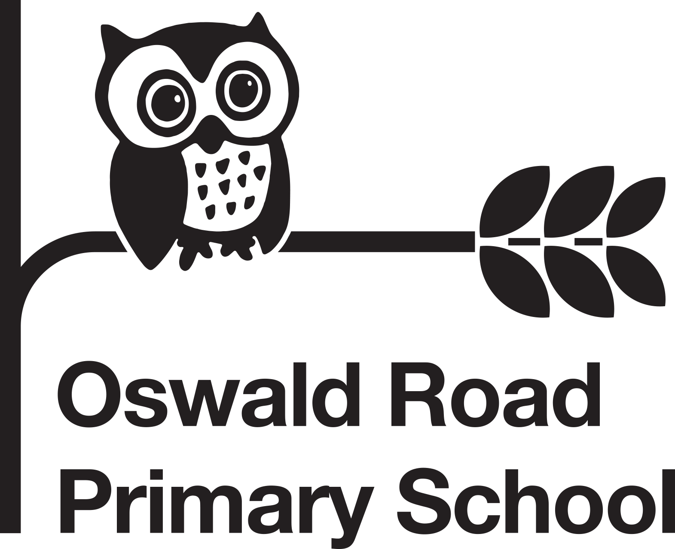

Oswald Road Primary School Curriculum Map: Reception
 | Autumn 1  05/09 – 21/10 | Autumn 2  31/10 – 16/12 | Spring 1  04/01 – 17/02 | Spring 2  27/02 – 31/03 | Summer 1  17/04 – 26/05 | Summer 2  07/06 – 21/07
Themes/Interests/Lines of Enquiry | Getting to know you!  Birthdays  Family  Harvest 11/09  BHM  Autumn  Diwali 24/10  European Languages Day 26/09  Halloween 31/10 | Julia Donaldson  Bonfire night 05/11  Light and dark  Remembrance Sunday 12/11  Hanukkah 15/12  Maps  Christmas | Winter  Winter  Lunar New Year 22/01  Internet safety 07/02  Valentines 14/02  Shrove Tuesday 21/02 | How does your garden grow?  Growing a seed  Duck life cycle  Spring  Holi 08/03  Science week 11-20/03  Comic/sport relief 17/03  Mother’s Day 19/03  Ramadan 22/03  Easter 09/04 | Once upon a time  Traditional tales  History of Oswald Road  Eid 21/04 | Animals of the world  Animals  Maps  Father’s Day 18/06
Core Texts | The Family Book  Kippers Birthday  Mouse House  Oats peas beans and barley grow  Autumn non-fiction  Meg & Mog | Zim Zam Zoom – Firework Poem  Room on the Broom  Superworm  The Scarecrows Wedding  Zog  Stick Man  Nativity non-fiction | Winter non-fiction  The Storm Whale in Winter  Lunar New Year non-fiction  Here Comes Jack Frost  Internet Safety –Smartie the Penguin  Mr Wolf’s Pancakes | Jack and the Beanstalk  Spring non-fiction  Over in the Meadow  Life cycle of duck non-fiction  Oliver’s Vegetables | Goldilocks and the Three Bears  The Three Little Pigs  Summer non-fiction  The Gingerbread Man  Lucy and Tom at School | Dear Earth  Hello Mr Whale  The Wide Wide Sea  We all went on Safari  Flip Flap Zoo  The Bug Collector  Jacob O’Reilly Wants a Pet
Shared Read  Texts | All are Welcome  Tiger who came to Tea  Ruby’s Worry  The Perfect Fit  Difference  Tidy  Funny Bones | How to catch a star  Whatever Next  What the Ladybird Heard  The Detective Dog  The Highway Rat  Me on the Map  Pick a Pine Tree | The Snowflake Mistake  The Snowy Day  Dot in the Snow  Goldy Luck and the Three Pandas  Little Red  The Internet is like a Muddy Puddle  Chapati Moon | The Growing Story  Mr Wolf and the Enormous Turnip  Little Red Hen  Ramadan non-fiction  The Elephant and the Bad Baby | Goldilocks and Just the One Bear  Ghanaian Goldilocks  The Three Little Wolves and the Big Bad Pig  Little Red and the Very Hungry Lion  Biscuit Bear  My Great Grandpa | Somebody Swallowed Stanley  Comotion in the Ocean  Tiddler  Poles Apart  Giraffes Can’t Dance  Billy’s Beetle  A Place Called Home
Communication & Language | Role Play – Home corner, dressing up people who help us, shop role play, Meg’s house  Small World Play - House and family characters, mouse house family, autumn, Diwali puppets, Halloween. | Role Play – Julia Donaldson settings, dark tent. Santa’s Grotto/Nativity  Small world – Julia Donaldson settings, planets, Christmas/ Nativity. | Role Play – Winter wonderland, Lunar New Year, Pancake kitchen/shop.  Small world – frozen world, Lunar New Year animal puppets, story settings. | Role Play –  Shop / Café / Garden Centre  Farm/ducks.  Small world – Jack & the Beanstalk, spring, planting, farm. | Role Play – traditional tales  Small world – traditional tale puppets | Role Play – Under the sea / Jungle / Pet shop / Vets  Small world – Under the sea, safari, jungle, bug house, homes of the world
Physical Development | Penpals  Fine Motor skills  PE: Space & Speed  -Being able to negotiate space and adjusting speed and direction when playing racing or chasing games with others  - Jumping off an object and landing appropriately.  Dance & Gymnastics | Penpals  Fine Motor skills  PE: Space & Speed  -Being able to negotiate space and adjusting speed and direction when playing racing or chasing games with others  - Jumping off an object and landing appropriately.  Dance & Gymnastics | F Penpals  Fine Motor skills  PE: Movement Exploration  - Choosing to move in different ways to represent different animals.  Dance & Gymnastics | Penpals  Fine Motor skills  PE: Movement Exploration  - Choosing to move in different ways to represent different animals.  .  Dance & Gymnastics | Penpals  Fine Motor skills  PE: Health  - To talk about things which contribute to good health eg: eating, sleeping, exercise.  - To begin to undress and dress independently when changing for PE.  - Looking at what constitutes a healthy, well- balanced diet.  Dance & Gymnastics | Penpals  Fine Motor skills  PE: Health  - To talk about things which contribute to good health eg: eating, sleeping, exercise.  - To begin to undress and dress independently when changing for PE.  - Looking at what constitutes a healthy, well- balanced diet.  Dance & Gymnastics
Personal, Social & Emotional Development | PHSE: Being Me in My World  Self-identity  Understanding feelings  Being in a classroom  Being gentle  Rights and responsibilities  Brushing teeth | PHSE: Celebrating Differences  Identifying talents  Being special  Families  Where we live  Making friends  Standing up for yourself  Brushing teeth | PHSE: Dreams and Goals  Challenges  Perseverance  Goal-setting  Overcoming obstacles  Seeking help  Jobs  Achieving goals  Brushing teeth | PHSE: Healthy Me  Exercising bodies  Physical activity  Healthy food  Sleep  Keeping clean  Safety  Brushing teeth | PHSE: Relationships  Family life  Friendships  Breaking friendships  Falling out  Dealing with bullying  Being a good friend  Brushing teeth | PHSE: Changing Me  Bodies  Respecting my body  Growing up  Growth and change  Fun and fears  Celebrations  Brushing teeth
Literacy | Essential Letters and Sounds Phase 2  Oral blending  Sounding out and blending with 23 new grapheme-phoneme correspondences (GPCs)  12 new harder to read and spell (HRS) words  Oxford University Press decodable readers.  Rising stars  Pleasure for reading book.  Recognising and writing own names  Initial sounds Segmenting CVC words  Writing CVC captions with HRS words | Essential Letters and Sounds Phase 3  Oral blending  Sounding out and blending with 29 new GPCs  32 new HRS words  Revision of Phase 2  Oxford University Press decodable readers.  Rising stars  Pleasure for reading book.  Writing CVC words Writing CVC captions and sentences with HRS words & high frequency words | Essential Letters and Sounds Phase 3  Oral blending  Sounding out and blending with 29 new GPCs  32 new HRS words  Revision of Phase 2  Oxford University Press decodable readers.  Rising stars  Pleasure for reading book.  Writing CVC captions &  sentences with HRS words & high frequency words | Essential Letters and Sounds Phase 3  Oral blending  Sounding out and blending with 29 new GPCs  32 new HRS words  Revision of Phase 2  Oxford University Press decodable readers.  Rising stars  Pleasure for reading book.  Writing sentences with  CVC words, HRS words, high frequency words,  longer words and  compound words | Essential Letters and Sounds Phase 4  Oral blending  No new GPCs  No new HRS words  Word structures – cvcc, ccvc, ccvcc, cccvc, cccvcc Suffixes  Revision of Phase 2 and Phase 3  Oxford University Press decodable readers.  Rising stars  Pleasure for reading book.  Composing and writing own sentences with phonetically plausible attempts at more complex words | Essential Letters and Sounds Phase 5 including alternatives and lesser-known GPCs  Introduction to Phase 5 for reading  20 new GPCs  16 new HRS words  Oxford University Press decodable readers.  Rising stars  Pleasure for reading book.  Composing and writing own sentences with attempts at more complex words  Extended sentences.  Key features of Narrative.
Mathematics | White Rose Maths:  Getting to know you.  Just like me!  Match and sort Compare amounts Compare size, mass and capacity Exploring pattern | White Rose Maths:  It’s me 1,2,3!  Light and Dark  Representing 1,2,3 Comparing 1,2,3 Composition of 1,2,3 Circles and triangles Positional language Representing numbers to 5 One more and less Shapes with 4 sides Time | White Rose Maths:  Alive 5!  Growing 6, 7, 8  Introducing zero  Comparing numbers to 5  Composition of 4 and 5  Compare mass  Compare capacity  6, 7 and 8  Comparing 2 amounts  Making pairs  Length and height  Time | White Rose Maths:  Building 9 and 10  Consolidation  Counting to 9 and 10  Comparing numbers to  10  Bonds to 10  3d shapes  Spatial awareness  Patterns | White Rose Maths:  To 20 and Beyond  First, then, now  Building numbers  beyond 10  Counting patterns  beyond 10  Spatial reasoning (1)  Match, rotate,  manipulate  Adding more  Taking away  Spatial reasoning (2)  Compose and  decompose | White Rose Maths:  Find My Pattern  On the Move  Doubling  Sharing groups  Even and odd  Spatial reasoning (3)  Visualise and build  Deeping understanding  Patterns and relationships  Spatial reasoning (4)  Mapping
Understanding of the World: Past and Present | Family photos  Name and describe people who are familiar to them  People who help us – vicar from local church and oral health team | Author visit  Local library  Nativity | People who help us – Dentist visit | People who help us –Morrisons | Once upon a time at Oswald Road  People who help us – RNLI | Blue Planet recount  Transport from the past.  People who help us – Vet visit, Dogs Trust
Understanding of World Technology | Coding week: Beebots  Technology area (CP) | Computing: Pic Collage (Zog)  Technology area (CP) | Computing: (Internet safety – Smartie the penguin)  Technology area (CP) | Technology area (CP) | Technology area (CP) | Computing: (Beebots – Animals)  Technology area (CP)
Understanding of the World People & Communities | RE: Believing  Which stories are special and why?  Christians and Muslims  Halloween  Diwali  Geography: Autumn walk  MFL: Spanish songs  Colorin Colorado | RE: Expressing  Which times are special and why?  Christians (Christmas)  Geography: Visit to library and walk to post box.  MFL: Spanish songs  Colorin Colorado  Feliz Navidad | RE: Living  What is special about our world and why?  Muslims  Geography: Lunar New Year  MFL: Spanish songs  Tengo Dos Manitos | RE: Believing  Which people are special and why?  Christians and Sikhs  Geography Spring walk to Field of Oz/Oswald Road Pocket Park/Chorlton Community Garden  Comic/sports relief (Geography)  MFL: Spanish songs  Tengo Dos Manitos | RE: Expressing  Which places are special and why?  Christians and Muslims  Eid  MFL: Spanish songs  ¡Hola! Super Simple Español | RE: Living  Where do we belong?  Christians, Muslims and Hindus  Maps  Geography: Visiting Blue Planet  MFL: Spanish songs  ¡Hola! Super Simple Español
Understanding of the World The Natural World | Science:  Senses (collecting leaves)  Body parts  Compare environments: Autumn (woods/forest)  Changing seasons: Harvest  Autumn (Geography)  Explore the natural world | Science:  Light and Dark  Explore the natural world  Compare environments: space  Senses (Bonfire night)  Bethlehem | Science:  Senses: winter (ice)  Winter (Geography)  Chit Potatoes  Explore the natural world  Science week 11-20/3/22 | Science:  Lifecycles  Cress/Beans  Plant Potatoes  Ducks  Spring (Geography)  Explore the natural world | Science:  Compare environments: Underwater environments  Explore the natural world  Senses: Summer walk  Summer (Geography) | Science:  Decay and changes over time  Dig up Potatoes  Explore the natural world  Compare environments animals live in
Expressive Art & Design | Music: Music in the Classroom: Getting Started: Sounds: Exploring sounds  DT:  Food: Halloween cake  Mechanisms: Split pin witches  Textiles: Collage mice  Junk Modelling (CP)  Creative Table (CP)  Art:  Drawing:  Painting faces  Textiles:  Collaging mice  Autumn leaf hedgehogs  Printing:  Harvest  3D form: 3D form:  Clay diva lamps  Junk Modelling (CP)  Creative Table (CP) | Music: Music in the Classroom: Getting Started: Sounds: Exploring sounds  DT: Structure: Rocket  Textiles: Firework wands  Food: Decorate biscuits  Junk Modelling (CP)  Creative Table (CP)  Art:  Drawing:  Pastel Fireworks  Calendar  Painting:  Scarecrows  Textiles:  Firework wands  Printing:  Christmas card  3D form:  Rocket  Junk modelling (CP)  Creative Table (CP)  Dance & Gymnastics | Music: Music in the Classroom: Getting Started: On the Beat: Duration (pulse, rhythm, metre) & Tempo  DT: Structure:  Textiles: Collaging hearts  Junk Modelling (CP)  Creative Table (CP)  Art:  Drawing and painting: Winter  Chinese dragon  Textiles:  Collaging valentine’s hearts  3D form:  Junk Modelling (CP)  Creative Table (CP)  Dance & Gymnastics | Music: Music in the Classroom: Getting Started: On the Beat: Duration (pulse, rhythm, metre) & Tempo  DT: Mechanisms: Create a moving picture with a leaver. (Easter Cards)  Textiles: Collaging ducks  Junk Modelling (CP)  Creative Table (CP)  Art: Drawing and painting:  Vegetables  Ducks  Spring  Collaging:  Ducks  3D form:  Junk Modelling (CP)  Creative Table (CP)  Dance & Gymnastics | Music: Music in the Classroom: Getting Started: In Tune: Pitch (melody)  DT: Structure:  Textiles: House (3 Little Pigs)  3D form: Salt Dough Gingerbread Man  Junk Modelling (CP)  Creative Table (CP)  Art:  Drawing: Summer  Traditional tales  Painting: Colour Mixing  3D form: 3 pigs houses  Junk Modelling (CP)  Creative Table (CP)  Dance & Gymnastics | Music: Music in the Classroom: Getting Started: Compose: Composition & Structure  DT: Structure: Build a ramp for a toy car  Food: Fruit kebabs  Junk Modelling (CP)  Creative Table (CP)  Art: Drawing: Animals & environments  Painting: Animals &  environments  3D form: build a ramp for a toy car  Junk Modelling (CP)  Creative Table (CP)  Dance & Gymnastics
Enrichment | Halloween  Harvest  Diwali  European Day of Languages  Vicar visit – Harvest talk  Oral health workshop | Remembrance Sunday  Bonfire night  Road Safety Week  Hanukkah  Christmas  Anti-Bullying week  Children in Need  Author visit/Library visit  Christmas Nativity Show | Lunar New Year  Internet safety Day | Spring Walk  Ducks  Pancake Day  World Book Day Mother’s Day  Comic/Sport Relief  Easter  Science week 11-20/03  RNLI visit | Eid  St Georges day  Amateur theatre company | Blue Planet Aquarium  Vet visit  Dogs Trust  Eid  Sports day  Father’s Day  Transition time  Healthy schools week

