  The Local Offer  Brings together Information and Advice in one place to make it easier for families of children and young people (aged 0—25) with SEND to find the services and support they need.  It has been developed by working with parents, young people, professionals and staff from a wide range of services. This group constantly keeps the local offer under review and is a work in progress.  Access the Local Offer for Manchester on:  www.manchester.gov.uk/sendlocaloffer  or  Google: Manchester Local Offer  Help & Advice can also be found on:  www.manchester.gov.uk  helpandsupportmanchester | 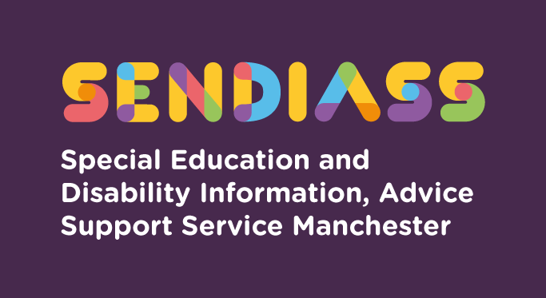  Helping parents, carers & young people  We are a statutory service offering free confidential, impartial advice and support to parents/carers children & young people (aged 0-25) with special educational needs and disability.    How to Contact IASM  Helpline  0161 209 8356  Monday-Friday 8.30am – 3.30 pm  or  parents@manchester.gov.uk  or  https://www.iasmanchester.org | Do you have questions about your child's Special Educational Needs ?  Need to talk to someone about your options or next steps with your child’s education?  Do you understand how to access the support you need?

How we work  Our service is confidential and free, and we offer support to parents, carers, children and young people up to the age of 25.  What does IAS Manchester do?  We provide the following:  - Advice, information and individual support about the special education needs system including Education, Health and Care (EHC) plans  - Support with education letters and meetings about your child’s SEN  - Support to make your views, choices and decisions known  - A confidential and impartial telephone helpline service  - Attendance at monthly parent/carer drop-ins in community locations  - Encourage partnership and dialogue between parents, Children’s Services (Education), schools and voluntary organisations  - Liaise with the Education, Health and Care Plan team and schools’ SENCOs to progress your issues | We Provide  Information on school admissions and appeals  Information on school exclusion  Information on disability discrimination  Support meetings in relation to SEN and disability issues  Advocacy in meetings  Informal disagreement resolution and mediation between parents, schools and Local Authority  Information on formal disagreement resolution and mediation services  Information on other avenues of support to the voluntary and community sector  Information on Health and Social care and the Local Offer  Help to make Parents’ voices heard to influence change and development of services  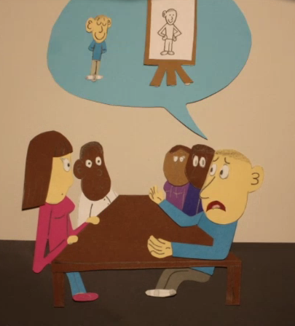  IASM wishes to thank Justin Lees for the artwork on this leaflet . |   For Young People  Our service must be impartial. That means we will be unbiased and we will not tell you what to do. We will give you the information you need so you can make your own choices.  We are a confidential free service. This means that your meetings will be private unless someone is in danger in danger of being hurt.  We can also support you on your journey into adulthood and provide advice, signpost to post 16 college, apprenticeships and training.  You can contact us on your own or with someone else's help. Your parent can contact our service on your behalf as well but we would need your permission to talk with them if you are 16 or over.

